A Project Report
On
Title
submitted for partial fulfillment of the requirements
for the award of the degree of
Bachelor of Technology
in
Computer Science
Submitted by 1.Harsh Agrahari (Computer Science) 2000290120069
2. Mohammad Ausaf (Computer Science) 2000290120096
3. Rahul Yadav (Computer Science) 2000290120123
Under supervision of
Prof. SHREELA PAREEK

KIET Group of Institutions, Ghaziabad
Dr. A.P.J. Abdul Kalam Technical University, Lucknow
MARCH, 2024
DECLARATION
I/We hereby declare that this submission is our own work and that, to the best of our knowledge and belief, it contains no material previously published or written by another person nor material which to a substantial extent has been accepted for the award of any other degree or diploma of the university or other institute of higher learning, except where due acknowledgment has been made in the text.

Signature
Name:-
Roll No.:-
Date:-

CERTIFICATE

This is to certify that Project Report entitled “ ” which is submitted by in partial fulfillment of the requirement for the award of degree B. Tech. in Department of Computer Science of Dr. A.P.J. Abdul Kalam Technical University, Lucknow is a record of the candidates own work carried out by them under my supervision. The matter embodied in this report is original and has not been submitted for the award of any other degree.
.

Date: 12/03/2024 Supervisor
Name: SHREELA PAREEK
(Designation)

ACKNOWLEDGEMENT

It gives us a great sense of pleasure to present the report of the B. Tech Project undertaken during B. Tech. Final Year. We owe special debt of gratitude to Professor (Name of Guide), Department of Computer Science, KIET, Ghaziabad, for his/her constant support and guidance throughout the course of our work. His/Her sincerity, thoroughness and perseverance have been a constant source of inspiration for us. It is only his cognizant efforts that our endeavors have seen light of the day.
We also take the opportunity to acknowledge the contribution of Dr. Pradeep Kumar Singh, Head of the Department of Computer Science, KIET, Ghaziabad, for his full support and assistance during the development of the project. We also do not like to miss the opportunity to acknowledge the contribution of all the faculty members of the department for their kind assistance and cooperation during the development of our project.
Last but not the least, we acknowledge our friends for their contribution in the completion of the project.
Date : 12/03/2024
Signature: Signature:
Name :Harsh Agrahar Name: Mohammad Ausaf
Roll No.: 2000290120069 Roll No.: 2000290120096
Signature:
Name :Rahul Yadav
Roll No.:2000290120123

ABSTRACT

In this project, we impliment the domain of medicinal plant identification, focusing on the application of machine learning and deep learning techniques. With the rich diversity of such materials in the world, accurate identification is essential, as misidentification can lead to confusion, adulteration, and a lack of trust in the traditional Ayurvedic or medical system(s). Our primary objective is to explore and harness the potential of transfer learning as an effective solution to this longstanding challenge. Transfer learning leverages knowledge acquired by a model in one task to enhance its performance in another, closely related task. To accomplish this, we have extensively examined the capabilities of renowned deep learning models such as ResNet-50 and Vgg16. Our study delves into the fundamental principles of transfer learning, considering its impact on the accuracy and reliability of medicinal plant classification. By adopting transfer learning, we utilize pre-trained models, specifically the ResNet-50 and Vgg16 architectures, which are well-recognized for their imagerecognition abilities. These models have already been trained on vast and diverse datasets, enabling them to capture and extract invaluable features from images, a crucial aspect of plant classification which is then leveraged while customizing these models for our particular use case. We used transfer learning, combining both fine-tuning and feature-extraction techniques to achieve accuracy of 98%.

TABLE OF CONTENTS | Page No.
DECLARATION……………………………………………………………………. | ii
CERTIFICATE……………………………………………………………………… | iii
ACKNOWLEDGEMENTS…………………………………………………………. | iv
ABSTRACT………………………………………………………………………..... | v
CHAPTER 1 INTRODUCTION PAGE NO.
1.1 INTRODUCTION TO PROJECT
1.2 PROJECT CATEGORY(INTERNET BASED, APPLICATION OR SYSTEM DEVELOPMENT, RESEARCH BASED ,INDUSTRY AUTOMATION, NETWORK OR SYSTEM ADMINISTRATION)
1.3 OBJECTIVES
1.4 PROBLEM FORMULATION
1.5 PROPOSED SYSTEM
1.6 UNIQUE FEATURES OF THE SYSTEM

CHAPTER 2. REQUIREMENT ANALYSIS AND SYSTEM SPECIFICATION
2.1 FEASIBILITY STUDY (TECHNICAL, ECONOMICAL, OPERATIONAL)
2.2 SOFTWARE REQUIREMENT SPECIFICATION DOCUMENT WHICH MUST INCLUDE THE FOLLOWING:
(DATA REQUIREMENT, FUNCTIONAL REQUIREMENT, PERFORMANCE REQUIREMENT
, MAINTAINABILITY REQUIREMENT, SECURITY REQUIREMENT)
2.3 SDLC MODEL TO BE USED

CHAPTER 3. SYSTEM DESIGN
3.1 DETAIL DESIGN
3.2 SYSTEM DESIGN USING DFD LEVEL 0 AND LEVEL 1
3.3 USE CASE DIAGRAM
3.4 DATABASE DESIGN
3.4.1 ER DIAGRAMS

CHAPTER 4. IMPLEMENTATION, TESTING, AND MAINTENANCE
4.1 INTRODUCTION TO LANGUAGES,TOOLS AND TECHNOLOGIES USED FOR IMPLEMENTATION
4.2 TESTING TECHNIQUES AND TEST CASES USED

CHAPTER 5. RESULTS AND DISCUSSIONS
5.1 USER INTERFACE REPRESENTATION (OF RESPECTIVE PROJECT)
5.1.1 BRIEF DESCRIPTION OF VARIOUS MODULES OF THE SYSTEM
5.2 SNAPSHOTS OF SYSTEM WITH BRIEF DETAIL OF EACH
5.3 BACK ENDS REPRESENTATION (DATABASE TO BE USED )
5.3.1 SNAPSHOTS OF DATABASE TABLES WITH BRIEF DESCRIPTION
CHAPTER 6. CONCLUSION AND FUTURE SCOPE

REFERENCES( REFERENCES SHOULD BE IN IEEE STANDARD)

CHAPTER 1
INTRODUCTION

  - INTRODUCTION
Medicinal plant leaves have long been utilized in traditional medicine. Identification of medicinal leave is a very challenging task. This task is often fraught with difficulties when undertaken without external resources or assistance. Accurate identification of the specific medicinal plants employed in the creation of herbal remedies is a critical aspect of the medicinal industry. The utilization of traditional plantbased medicines alongside pharmaceutical drugs is a growing trend in many countries, signifying a wealth of opportunities in this field. To tackle the challenge of medicinal plant leaf identification, our research explores major image recognition algorithms of Image analysis, a fundamental method in this context, plays a pivotal role. The integration of image analysis, deep learning, and AI techniques enhances the precision and reliability of medicinal leaf identification, thereby contributing to the broader landscape of traditional medicine and herbal remedy preparation. Through this research, we aim to shed light on the potential and significance of these technological advancements in the realm of traditional medicine.
  - PROJECT CATEGORY
INDUSTRY AUTOMATION
  - OBJECTIVES
1. The main objective is of identification of the medicinal plants are the lack of knowledge and resources, to identify these leaves (by extension, the plants).
2.Computer vision-based image processing is one of emerging techniques to computerize such tasks by emulating the human visual system.
3.To integrate the model into a well-functional platform for end-user usage.
1.4 PROBLEM FORMULATION
The main issue with the identification of the medicinal plants are the lack of knowledge and resources, to identify these leaves (by extension, the plants) one either needs an expert or a manual/guide.
Making matters worse, the very availability of the resources is scarce, hence there is a need to automate the identification/detection procedure.
  - PROPOSED SYSTEM
The objective is to achieve a high level of accuracy and reliability in medicinal plant classification, leveraging the ResNet-50 and Vgg16 architectures. The researchers employ transfer learning techniques, including fine-tuning and feature extraction, to customize these models for their specific use case. Their ultimate goal is to attain an accuracy rate of 98% in medicinal plant classification

1.5 UNIQUE FEATURES OF THE SYSTEM
After Loading our pre-trained models, we freeze the parameters of the model, essentially resulting in the retention of the default weights and knowledge. The classification layers (the final fully connected layer in ResNet and 3rd Convolutional layer in Vgg16) of the model, which are responsible for mapping features to class labels, are replaced with a custom classification layer. The new classification layer is specific to the number of classes in your dataset. Each output unit in this layer corresponds to a particular class. This custom layer allows the model to adapt to our specific image classification task

2.1 FEASIBILITY STUDY (TECHNICAL, ECONOMICAL, OPERATIONAL)
The technical feasibility examines the capability of applying machine learning and deep learning techniques, specifically transfer learning, to the domain of medicinal plant identification. It involves assessing the availability of suitable datasets, the effectiveness of deep learning models such as ResNet-50 and Vgg16 in image recognition, and the feasibility of implementing transfer learning techniques to enhance model performance.

3.1 DETAIL DESIGN
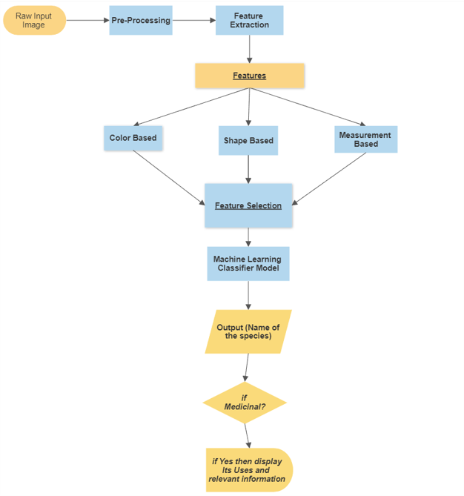

3.2 SYSTEM DESIGN USING DFD LEVEL 0 AND LEVEL 1
LEVEL 0
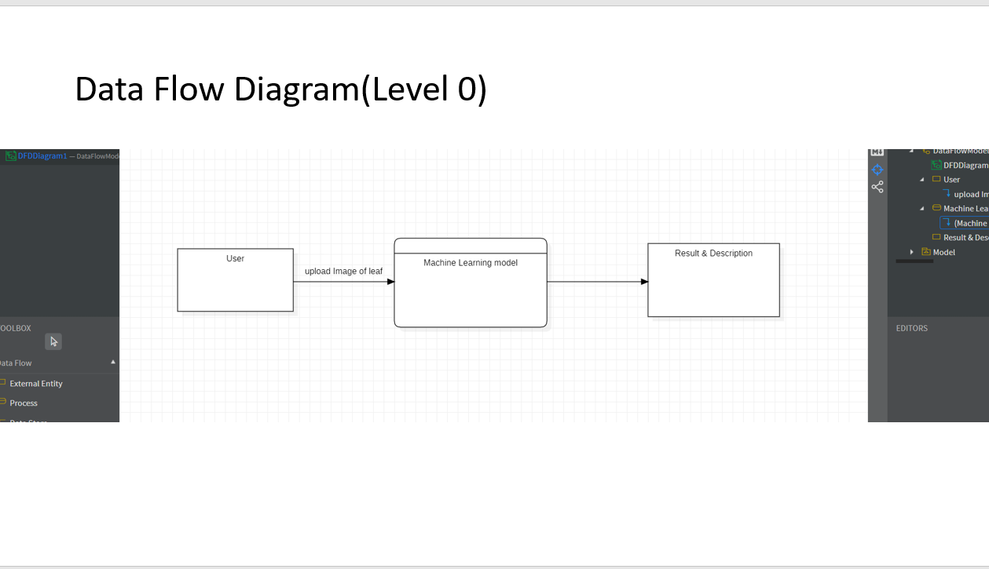
LEVEL 1
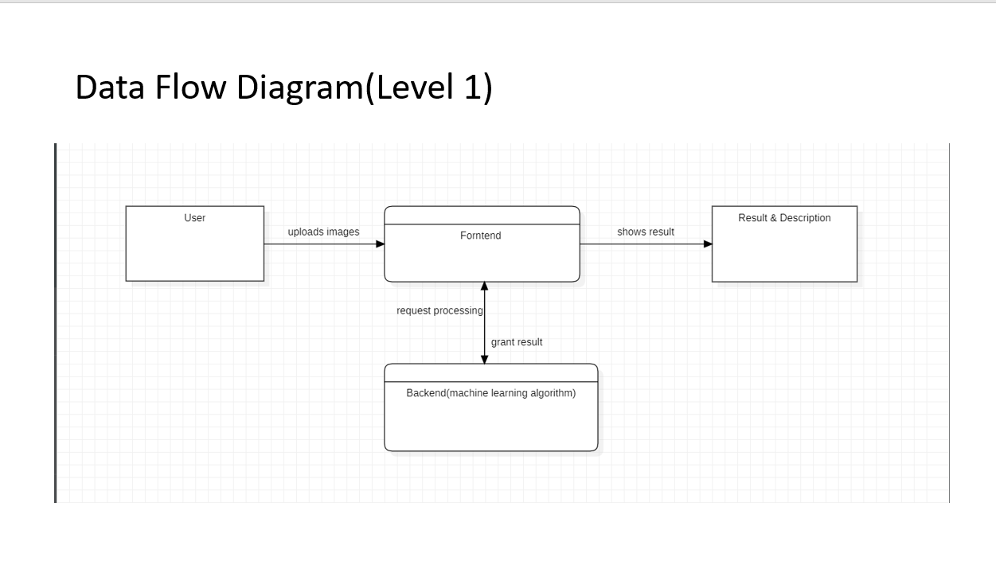

LEVEL 3
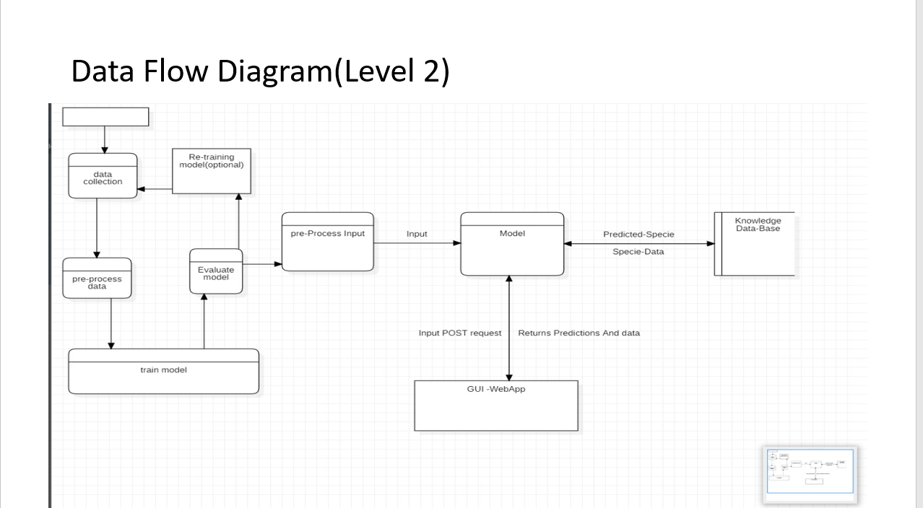

3.3 USE CASE DIAGRAM
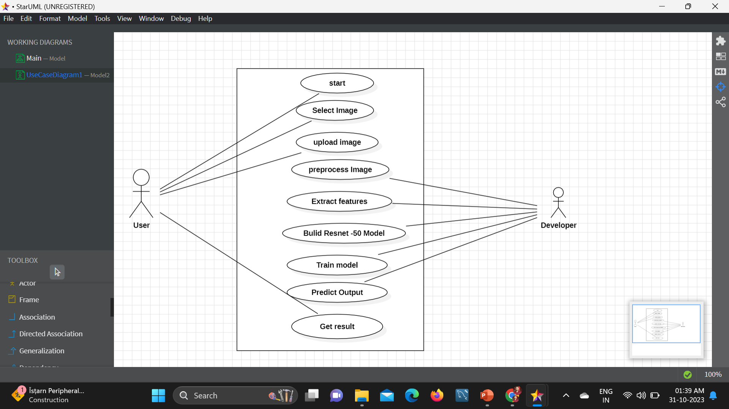
3.4 DATABASE DESIGN
3.4.1 ER DIAGRAMS
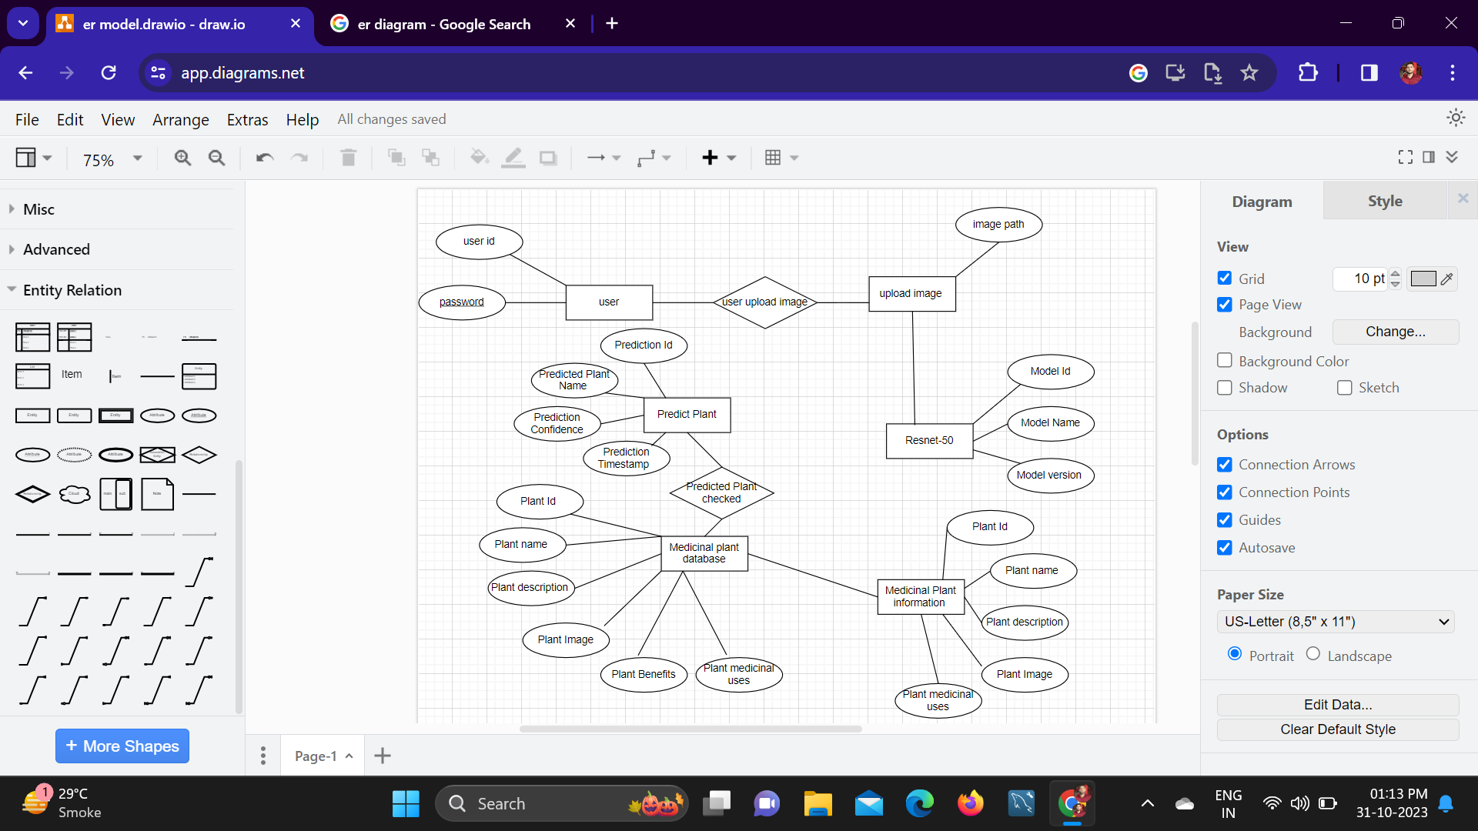

6. CONCLUSION AND FUTURE SCOPE
Our comparative analysis of the ResNet50 and VGG16 models, considering both top-1 and top-5 performance metrics reveals differences in their performance. Both models exhibit a high top-1 accuracy, achieving approximately 98.37% and 86.38%, indicating their proficiency in correctly predicting the most likely class label for the majority of samples. However, ResNet50 emerges with a more balanced approach, achieving a higher precision of 72.20% compared to VGG16 of 23.0% in top-1 predictions. While both models struggle with low recall—ResNet50 at 7.4% and VGG16 at 6.7%—implying their inability to capture a proportion of positive samples, ResNet50 excels in this regard. The F1 scores also indicate these imbalances, yet ResNet50 performs better.

REFERENCES

[1] Kalyoncu, Cem, and Önsen Toygar. "Geometric leaf classification." Computer Vision and Image Understanding 133 (2015): 102-109.

[2] Hu, Rongxiang, Wei Jia, Haibin Ling, and Deshuang Huang. "Multiscale distance matrix for fast plant leaf recognition." IEEE transactions on image processing 21, no. 11 (2012): 4667-4672.

[3] Hu, Rongxiang, Wei Jia, Haibin Ling, and Deshuang Huang. "Multiscale distance matrix for fast plant leaf recognition." IEEE transactions on image processing 21, no. 11 (2012): 4667-4672.

[4] Kumar, Munish, Surbhi Gupta, Xiao-Zhi Gao, and Amitoj Singh. "Plant species recognition using morphological features and adaptive boosting methodology." IEEE Access 7 (2019): 163912- 163918.

[5] Yang, Chengzhuan, and Hui Wei. "Plant species recognition using triangle-distance representation." IEEE Access 7 (2019): 178108- 178120.

[6] Wu, Stephen Gang, Forrest Sheng Bao, Eric You Xu, Yu-Xuan Wang, Yi-Fan Chang, and Qiao-Liang Xiang. "A leaf recognition algorithm for plant classification using probabilistic neural network." In 2007 IEEE international symposium on signal processing and information technology, pp. 11-16. IEEE, 2007.

[7] Hu, Rongxiang, Wei Jia, Haibin Ling, and Deshuang Huang. "Multiscale distance matrix for fast plant leaf recognition." IEEE transactions on image processing 21, no. 11 (2012): 4667-4672.

